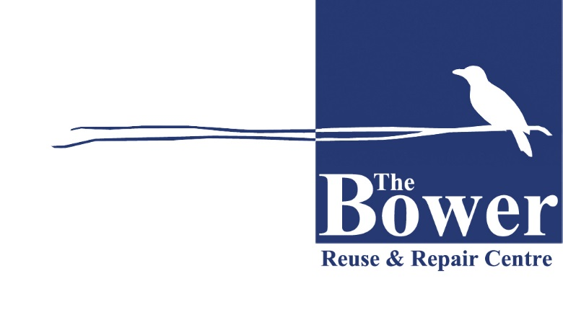
The Bower’s Collection & Rehoming Service
Script for Customer Service Officers

The below is a suggested script for Council Customer Service Officers to use when answering calls from residents requesting a bulky waste collection service.

The Bower provides a collection service for residents in <LGA name>. They accept household furniture, bikes, some electronic appliances and building materials, bric-a-brac, kitchenware and books.
Would you like to contact them first?
Are any of the items in good working condition and can be used again or resold?
Yes

No
Find out more about donating to the Bower at www.bower.org.au/collections
The Bower can also advise you find other charities and organisations who will accept other goods such as large and bulky items, mattresses, bulky whitegoods, clothing and textiles. Visit their reuse tool at www.reuse.bower.org.au

Continue as per Council processes

