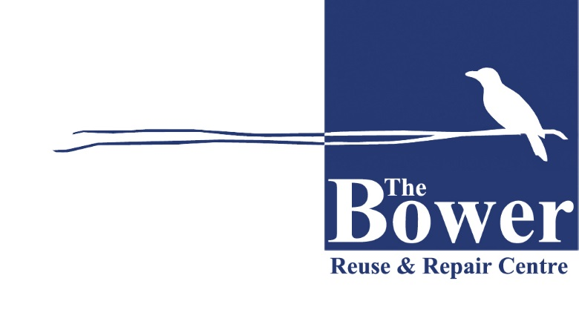
The Bower Reuse & Repair Centre
Do you have something you no longer want or need but it’s just too good to throw away?

Contact the Bower
www.bower.org.au/collections
Email: reuse@bower.org.au
Household furniture ~ Kitchenware & bric-a-brac ~ Bikes ~ Books ~ Building Materials

