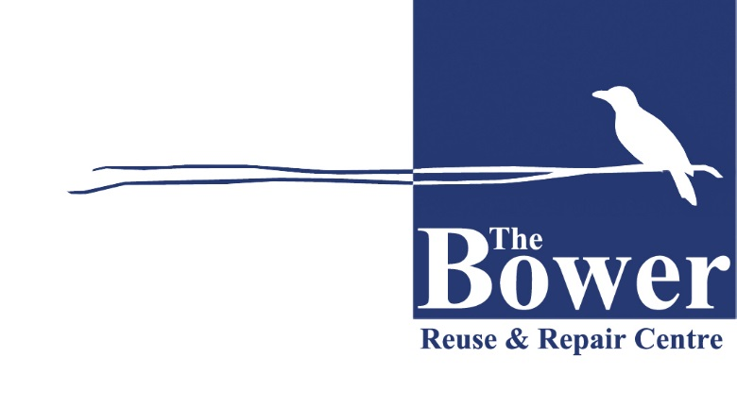
The Bower’s Collection & Rehoming Service
TOP 10 UNACCEPTABLE ITEMS

The Bower cannot accept the following items:
Item |  | Reason
1 | Mattresses | Health regulations
2 | Furniture made using chipboard or MDF | Cannot be recycled
3 | Dirty/ripped/stained lounges and sofas | Cannot be resold
4 | Washing machines and dishwashers | No facilities for testing
5 | Old bulky televisions (CRT) | Cannot be resold
6 | Baby/children’s items - cots, prams, toys | Safety regulations
7 | Kitchen fitouts and large goods - stoves, microwaves, large fridges and freezers | Too bulky
8 | Pianos and organs | Too bulky
9 | Fitness equipment - walking machines, rowers, cross-trainers, ab-busters | Too bulky
10 | Encyclopaedias and magazines | Cannot be resold

The Bower, subject to discretion, accepts household furniture, kitchenware and
bric-a-brac, bikes, books and small amounts of building materials.

