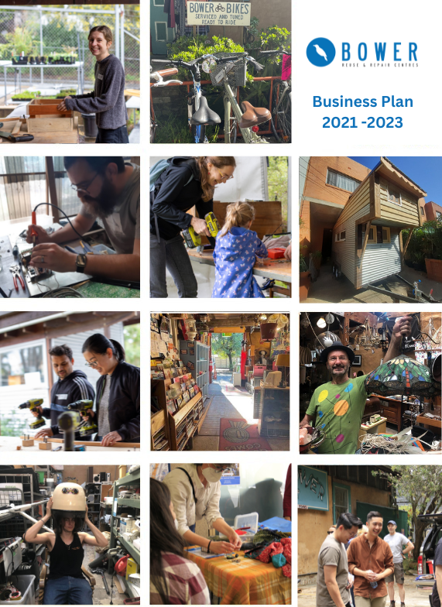
3

Subject Page
Executive Summary 3
Organisational Structure & Identity
The Bower Reuse and Repair Centre is a Co-operative Limited

Registered with NSW Fair Trading since 4 May 1998 Registration Number NSWCO5363

ABN: 51412061029 from 12 June 2000
GST Concession from 1 July 2005.
FBT Rebate from 1 July 2005.
Income Tax Exempt from 1 July 2000.
Not for Profit social enterprise registered as a charity with ACNC Public Fund approved by Register of Environmental Organisations Deductible Gift Recipient status from 1 Jul 2000
Charitable Fundraising Authority Registration number CFN/20440
Registered with NSW Trade & Investment Office of Liquor, Gaming and Racing.
Location and Contact details
Location: 34/142 Addison Road, Marrickville, NSW 2204
Opening hours Store:
Monday – Saturday: 10.00 am – 5.00 pm Sunday: 10.00 am – 4.00 pm.
Opening hours Collection and Rehoming Service:
Monday – Friday: 9.00 am – 5.00 pm.
Business hours phone number: 02 9568 6280
Website: http://www.bower.org.au
Cooperative Manager; Guido Verbist gm@bower.org.au
Governance
Board 7 Directors (5 Member directors and 2 Independent Directors) - 2-year terms
Gavin Hull - Chair and Member Director
Terry O’Donnell - Treasurer Member Director Peter Carroll - Secretary and Independent Director Amanda Buckland - Member Director
Ulrike Zimmermann - Member Director Oliver Bradshaw - Independent Director Liam Noble - Member Director

Governance rules are adapted from the model rules based on the Co-operatives Act 2012 and approved on 23 September 2015

Annual membership is $15 and $12 for concession card holders.
Insurances
Public & Product Liability $20,000,000 Policy number MFC T0677
Voluntary workers Personal Accident: Death & Capital benefits $30,000
Weekly Benefits $600 General Insurance for Building, theft and business interruption Association Liability Professional Indemnity $1,000,000
Directors & Officers $1,000,000 Association Reimbursement $1,000,000
Workers Compensation Policy Number: WC295605157
Truck Insurance: Allianz Commercial Motor Policy Number 171A010552VSD

Business description

Business Type and Structure

The Bower is a co-operative and registered environmental charity with the dual purpose of:
    - benefiting members (meeting their common needs and aspirations), and
    - benefiting the natural environment (e.g., by reducing waste to landfill).

1(a) A Co-operative

The Bower Reuse & Repair Centre Co-operative Ltd (‘The Bower’) is a member-based community organisation, formally structured as a ‘non share trading’ Co-operative, registered under the NSW Co-operatives Act.

At the Annual General Meeting (AGM) the members elect member directors (nominated by the membership) and independent directors (nominated by the Board) to the Bower’s Board of Directors.

Directors volunteer their time and expertise to oversee the governance, mission and broad strategic direction of the organisation on behalf of members.

The Co-operative Manager (General Manager) is engaged by the board and is broadly responsible for ‘operationalising’ The Bower’s mission via long-term planning, and day-to-day management. The Board provides the Co-operative Manager with a range of ‘delegated authorities’ for this purpose.

Under this structure, the future of the organisation is secured beyond the commitment of any single person.

All profits remain in the organisation and are reinvested in further expansion of the business model and its services to the community and members.

1(b) A Registered Environmental Charity

The Bower is one of approx. 600 registered environmental charities included on the Commonwealth Government’s ‘Register of Environmental Organisations’.

The Register is a list of environmental organisations eligible to receive tax deductible donations. The Bower maintains a public fund entitled ‘The Bower Fund’ for this purpose. Donations to this fund are tax deductible.

As a registered environmental organisation, the Bower has been endorsed by the ATO as an income tax exempt charity and has a range of GST concessions available.

As a registered environmental organisation, the Bower’s principal purpose must be:
“(a) the protection and enhancement of the natural environment or of a significant aspect of the natural environment; or
(b) the provision of information or education, or the carrying on of research, about the natural environment or a significant aspect of the natural environment

Organisation Objectives and Mission

The objectives of The Bower as stated in our Rules are:

- To protect and enhance the natural environment, particularly aspects of the environment affected by waste generation and landfill by:
  - Avoiding and reducing the amount of 'hard waste' going to landfill.
  - Raising awareness of the value of waste avoidance and reduction through resource recovery, reuse, repair and recycling.
  - Generating employment opportunities and skills training in the community.
  - Providing affordable goods sourced from the waste stream to low-income earners and other disadvantaged groups in the community.
  - Encouraging community awareness of environmentally responsible design and manufacture.
  - Advocating for long-life design, repairable products and the use of sustainable, recyclable materials for appliances and furnishings.
  - Providing benefits to the community via these objectives.
  - Involving the community in the development and achievement of these objectives.

- Establishment of the Public Fund:
To maintain a public fund to be called the Bower Fund for the specific purpose of supporting the environmental objects/purposes of The Bower Reuse and Repair Centre Co- operative Limited.

The Bower’s Mission is threefold:
  - Environment: to reduce the amount of waste entering landfill by reclaiming household items for repair, reuse and resale.
  - Creativity: to encourage reuse via repair and upcycle workshops; and
  - Community: to provide affordable goods to low-income earners and other disadvantaged groups and to generate local employment.

Business / Organisation History

The Bower was created (registered) in 1998 on the initiative of five Sydneysiders appalled by all the waste going to landfill every year. They decided to act at a small scale and to create a reuse and repair centre with the aim of recovering those resources for reuse.

The founders secured money for the design and construction of a sustainable building (‘the barn’) that would showcase reuse and repair. Built from straw bales, all architectural components from the doors to the roof were salvaged from the streets of Sydney. The Bower handed over ownership of the building to the Addison Road Community Centre (ARCC) for long- term community benefit and as an investment to improve the services of the ARCC.

The Bower shop opened its doors and commenced trading on 15th March 1999.

Since its inception the Centre has continued to develop and grow, increasing the number of resources we recover from landfill for reuse or repair:

    - The backyard has been terraced and more sections are now paved and shelved to better store greater amounts of salvaged building, plumbing and gardening supplies.
    - Two electrical workshops, and a timber repair workshop (now utilised by the men’s shed) were built from salvaged building materials, and relocated as sales and customer demand grew. The timber workshop was relocated to the rear awning to minimise noise and dust, and becoming an excellent member resource.
    - A mezzanine level was built to house an office space, and in 2009 a second mezzanine level was unveiled as our ‘Eco-Library’ – this area was recently reorganised to house books and kitchenware for sale, creating additional ground floor space for furniture.
    - A staffroom/kitchen was built behind the sales counter so that it could be used by employees as a rest and a storage space;
    - In 2010 The Bower installed a wheelchair access ramp.
    - In 2013 a covered bike shed was constructed in the backyard behind the kitchen.
    - In July 2013, The Bower signed a license agreement to operate a second premises (primarily as workshop space and men’s shed) at 107 Redfern St, Redfern; and then in 2017 at Parramatta Hunter Street which is now a workshops space and women’s shed.
.

Business location, service area and facilities

Marrickville:
The Bower ‘Barn’ (comprising the office and shop) is located within the Addison Road Community Centre in Marrickville, originally the site of an old army barracks. Re-using such a utilitarian site had great appeal to the founders of The Bower. An additional drawcard was the presence of Reverse Garbage in the same Centre, a like-minded reuse centre focused on industrial waste. The group seemed complimentary to The Bower which focuses on domestic waste.

The Addison Road Centre is easily accessible by public transport, bikes and vehicles for those wishing to donate/purchase larger goods. The Centre’s Sunday Organic Market attracts lots of extra visitors to the store.

Redfern:
The Bower utilises a fitted workshop space at an artists’ hub at 107 Redfern Street courtesy of a City of Sydney accommodation grant.

This initiative is based on a long-standing partnership between The Bower and Sydney TAFE Outreach to educate the community about sustainability. This space was retrofitted by Sydney TAFE to help kick-start social enterprises such as Curb Collective, Palletable Furniture and HoboGro but also to conduct workshops for people interested in learning techniques to repair and upcycle pre-loved goods. Individuals can also rent a bench in the workspace to design and build their own recycled projects. The Bower continues to partner with Sydney TAFE Outreach to conduct their Certificate I “Introduction to Building and Construction” course and Pathways programs with Correctional Services.

Parramatta:
The Bower to outreach further into Western Sydney established with the support of the City of Parramatta Council a shop in Hunter Street which has since been converted into a workshop space for our DIY and woodworking and repair cafes for western Sydney. We also host a women’s shed and specific courses in woodworking for women through the Habitat for Humanity program. Our House to Home program uses our Parramatta space as a hub for distribution goods to those in need.

The 3-pillar organisational-business model
The Bower Reuse and Repair Centre’s unique organisational model is inherent in its name (“Reuse and Repair”) and is reflected in the 3 pillars on which the Bower is built.
The organisational model aims to establish the Bower as a credible business that provides quality services in response to market needs while fulfilling social and environmental benefits.

Creating a sustainable economy
By collecting and selling pre-loved goods we not only create a local economy that provides both affordable goods, employment and training opportunities, we also help build sustainable communities and protect the environment. The vast majority of community recyclers such as the Salvation Army and St Vincent De Paul Society treat recycling as a revenue stream to finance other programs. Our critical difference is the sustainability education we deliver to the community to encourage long-term environmental change.
Uniquely, The Bower looks beyond the traditional 3Rs of Reduce, Reuse, and Recycle through our ongoing commitment to repair and upcycling of goods, exemplified by our electronic and furniture repair workshops and our recent in-house upcycling and production lines. These initiatives allow us to sell and divert significantly more goods from landfill and create more employment opportunities than other community recyclers.

Education of the community
The Bower has consistently invested in community education via workshops, trainings, support for social enterprises, consignment programs and also through recent inspirational initiatives such as the Repair Café, the Tiny House, an auction and the Christmas tree built with recycled materials.

The Bower seeks to match its unique, innovative and popular workshops with a robust, long- term education and marketing plan, which utilises its strengths in creative and inspirational projects, to engage and encourage the community to participate in our reuse and repair programs, thereby diverting more waste from landfill.

Working with Councils
The Bower has developed a unique Reuse and Referral Service (RRS) which it offers to a large number of Councils. If The Bower cannot accept goods, the RRS service refers local residents to one or more of the 1,000 recycling organisations on our database in a proactive attempt to divert these goods from landfill. We recently invested in new database software to measure goods diverted from landfill in tonnage, which is a more relevant measure for Councils.
The Bower’s strategic relationship with Councils will hopefully allow us to consult with them on the best way to gradually introduce the concept of “user pays” and move away from the current funding/support-based mechanism. Last but not least, we work with Councils on the promotion of reuse and repair via a range of educational workshops within their communities.
The triple bottom line is the chosen framework for The Bower to measure its organisational success for the promotion of sustainable communities. In addition to our social impact, we give equal importance to our environmental and economic performance. Environmental, social and financial sustainability is the standard and best way to present, report and evaluate The Bower’s work and success.
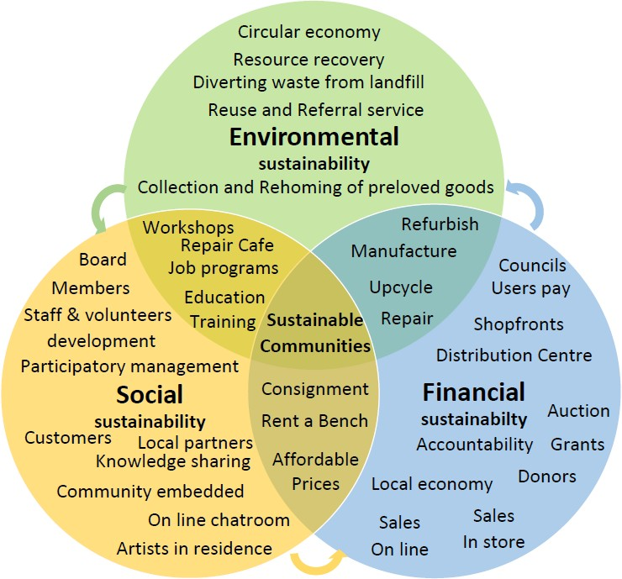

WH&S and Waste Management

The Bower has an extensive set of policies which are available to all members and staff. The following overview is a summary of relevant WH&S and Waste Management policies.

WH&S

  - Strict safety procedures and policies are in place for all staff working on the Bower premises: Policy and Procedure Handbook in place and available for staff and volunteers.
  - Use of Personal Protection Equipment is mandatory.
  - Chemical products stored safely and MSDS (Material Safety Data Sheets) available.
  - Fire extinguishers, Fire blankets and Emergency and Exit lighting are installed.
  - Risk Management plan and evacuation procedure with wardens is in place.
  - Map with exits and fire extinguishers displayed at different places in building.
  - First Aid kits present at all locations.
  - Twice yearly fire safety and evacuation drill is being held.
  - First Aid training provided.
  - Safe lifting & handling of goods training provided and signs to remind staff displayed.
  - Incident reporting and grievance policy in place.
  - Work safe plans produced for specific hazardous tasks (see example).
  - Risk assessment made for specific events (see example).
  - Police check and working with children check is mandatory for anyone working with children.
  - Program in place to test and tag all electronic items used and sold.
  - Wheelchair access ramp and safety railing in place
  - All job descriptions and Bower employment policies reviewed by external consultants in August 2021.

Waste management

Only 5% of all incoming goods go to landfill thanks to a thorough in-house resource recovery comprising the following steps:

  - Waste Triage and relocation of reusable parts to hardware, timber or other departments.
  - Paper and cardboard separated into dedicated bins and picked up fortnightly by waste manager contractor http://www.sita.com.au/commercial-solutions/collection-disposal/
  - Glass, plastic, cans separated into dedicated bins and picked up weekly http://www.sita.com.au/commercial-solutions/collection-disposal/.
  - E-waste (computers and electronic appliances) separated into dedicated bins and storage and picked up biweekly by ACE Recycling http://www.acerecycling.net.au/
  - Ferrous metals separated and picked up by ACE Recycling or taken to recycling facility by the Bower truck http://www.acerecycling.net.au/.
  - Untreated timber collected and sold or reused in our workshops and Tiny House courses.
  - Remaining fraction – which is estimated at 5% of all incoming goods goes to landfill.

The Bower’s Products and Services

- A Reuse Centre

Reuse of pre-loved goods and selling them in our secondhand store represents not only the core revenue stream of The Bower but is also the core objective of The Bower in response to the culture of disposal, over consumption and waste production.

Historically, The Bower strives to use revenue generated from the store to further expand its geographical reach across Sydney and address waste management problems at a higher level and through education. The Bower aims to be a resource centre for sustainable living and as such provides a wide range of diverse services to the community.

Second-Hand Shop

The second-hand shop traditionally has been and remains a key revenue stream, or ‘core businesses. The Bower’s main source of funding here is the sale of secondhand goods donated from Sydney residents or salvaged from city streets. Obtaining stock for free ensures that we are dealing directly with the symptoms of our disposable society, collecting only those goods that would otherwise end in landfill. Depending on their sale ability, goods will remain in the store between 1 day and 6 months but in the end 95% will find a new home.

Funds raised through the repair and sale of pre-loved goods provide approximately 40% of The Bower’s total revenue.

Other benefits of this practice include maintaining low to no overheads on stock and the ability to maintain low prices for customers.

One of the aims of The Bower is to provide affordable goods to low-income earners and other disadvantaged groups in the community. To encourage quick turn-over of pre-loved goods in the shop, the prices on the floor are revised every week.

Due to the nature of sourcing these items, it is impossible to create a comprehensive inventory of stock. Items collected predominantly fall into the following categories:

- Bric-a-brac: picture frames, vases, postcards, candles, figurines, small decorative pieces and more …
- Electrical devices: lamps, sewing machines, heaters and fans, CD & record players, phones, computers, kitchen appliances, tools and whitegoods, all tested and tagged by our electrician.
- Hardware: tools, bolts, nuts, doorhandles ...
- Stationery: paper, files, pen and pencils, diaries ...
- Kitchenware: plates, cutlery, Tupperware, coffee makers, flasks, pots, pans ...
- Books, CDs, DVDs & records
- Chairs: office chairs, dining chairs, garden chairs ...
- Games and sports: golf clubs, bike helmets, balls, skis ...
- Toys: fluffy, jigsaw puzzles ...
- Furniture: cupboards, tables, armchairs, drawers ...
- Building materials: wood, metal, tiles, paints ...
- Gardening materials
- Bikes and bike parts

On-line Shop
The Bower introduced an on-line shop in September 2015 to supplement and add value to our core business by:
- Reducing our shop footprint, i.e. the need to collect and display goods as they can be sold directly from the donor’s location.
- Attracting new clientele who may not be local.
- Allowing us to sell high-end quality goods which are harder to sell in the store.
Customers can pay on-line via PayPal or via the phone or they can ask to have an item on hold for 24 hours and come in the store to pay for and collect the goods. We courier the goods through Australia Post.
The bulk of the items will be sold via our website and more recently Facebook Marketplace http://bower.org.au/buy-goods/ More artistic and creative items can also be sold via Etsy.
https://www.etsy.com/shop/BowerCoOp?utm_source=theorangeappforfaceb&utm_medium= api&utm_campaign=api
Our primary on-line media platform for sales, promotion and interaction with our followers is still via our Facebook and Instagram pages. We also have an email subscribers list of over 15,000.

Consignment service

In addition to secondhand donations and salvaged goods, The Bower also supports members working under the ethos of Reuse and Repair through our Consignment Section.
Under our Consignment Policy and Agreement, members can sell in the Bower’s store any item they repaired or restored themselves, with The Bower retaining 30% of the sales price as standard commission.
Consignment objects are as varied as in the rest of The Bower, with armchairs, bikes, desks, tables, cases and machinery all featuring at one time or another.
Although the consignment program is our flagship program in terms of inspiration and promoting the potential of reuse, the sale of ‘consignment’ items currently accounts for only 5% of our total revenue.
The Bower recently introduced its own upcycling programs for the production of goods such as benches made from old bedheads and salvaged hardwood, tool and possum boxes made from salvaged plywood, storage boxes made from salvaged pallets and tables, chairs and dressers restored re-upholstered or given shabby chic finishes.

Community work
Working with local communities and supporting local initiatives has always been high on The Bower’s agenda. Not only is it a Bower objective to provide access to affordable goods, training and employment opportunities, but it is also the best way to inform and engage the public in our main objective of diverting waste from landfill.

The Bower is itself a social enterprise providing employment and educational opportunities to the community. In addition, the Bower has supported self-sufficient community enterprises such as “Curb Collective” which specialised in upholstery.
The Bower also has established partnerships with Alfalfa House Community Food Co-op in Enmore and the Asylum Seeker Centre in Newtown. The Bower provides a training venue and materials for Sydney TAFE Outreach courses and for NSW WIRES members to build bird boxes.

A Repair Centre
As reflected in The Bower’s name, we see promoting repair of pre-loved goods as a key mission in addition to promoting reuse.

The primary objective of promoting repairs is to counter our throwaway culture and its consequent environmental impact, stimulated and driven by consumerism.

The Bower introduced its own in-house repair services early on and has gained extensive expertise in repairing a range of goods such as electronic appliances, computers, bikes and furniture. This has resulted in a variety of repair services which we continue to expand.

Electrical goods and repairs

As increasing the e-waste capacity in Sydney becomes more and more critical each year, The Bower is committed to diverting as many electrical appliances as possible from landfill.

Under the leadership of our in-house repairs, who are certified for testing and tagging, and with the assistance of volunteers under supervision, The Bower is able to test and repair approximately 50% of all the electrical goods received as donations.

All the electrical appliances we then sell, are tagged so that the customer knows the condition of the item: an 'OK' tag means that the item was tested safe and is working, whereas an 'AS IS' tag indicates that the item is partially usable, sold for parts or requiring service.

Nevertheless, some electrical goods have low to no reuse value, such as old TVs, phones or VCR recorders. Approx. 25% of accepted electrical goods fit that criterion. The Bower has established a collection system in partnership with ACE Recycling resulting in 100% diversion from landfill of all accepted electrical goods including household items, computers and phones.

Furniture repairs

From its inception The Bower has engaged in furniture repair. The amount of good quality furniture that is thrown away because people have no interest, knowledge or time to repair them is astonishing and contributes significantly to Sydney’s waste problem. We currently repair approx. 10% of all donated furniture. With increased resources, time and space we could repair more.
The small furniture repair workshop is relocated to 107 projects at Redfern where bespoke furniture is repaired, restored or bespoke items can be made. We aim to increase this component of our work in the near future.

From 2011, we have hosted the Marrickville Men's Shed has used the workshop twice a week. The Men’s shed repairs furniture donated to The Bower and more recently assist with cultural boxes in cooperation with Gundwirra Aboriginal and Torres Strait Islands organisation which is based in Rozelle.

Bike repairs
The construction of the covered bike shed in 2013 generated renewed interest in our bike repair service. We currently have two people helping out with repairing and assembling donated bikes and preparing them for sale. We also undertake bike maintenance repair workshop at Parramatta and Marrickville and can do these at nay location in Sydney such as at Council events.

Paid repair service
Due to popular demand, we have decided to offer customers the opportunity to bring in their broken goods which they would like to hold on to but lack the skill or time to repair themselves.
We take bookings for repair of electronic appliances, bikes and furniture and commissioned projects as long as we can use second-hand materials and have the available skills, tools, space and time.
When the customer delivers the item, we provide a quote and request a 50% upfront payment before commencing. Our rate for repairs is $40/hour plus materials at cost. Customers can pay by cash, credit card or bank transfer. A warranty and refund policy are in place for this service.

Repair Café
Repair Cafés are free meeting places for local communities. Repair Cafes are all about learning the art of repair in a collaborative setting and fostering a culture of creativity, repair and reuse.
The Repair Café concept originates from Europe and The Bower was the first to introduce it in Australia. Thanks to a successful crowdfunding campaign we were able to open our Repair Café in May 2014.
A Repair Café is an event with complementary objectives to those of The Bower Reuse and Repair Centre:
- Repair items, extending their usable life. This in turn avoids the need for disposal and saves landfill and associated CO2 emissions (from disposal and replacement products).
- Re-learning the art of repair. Developing skills that have been in decline for several generations, empowering people to fix things and take pride in their new-found practical abilities.
- Encouraging people to join in with community events with like-minded others, by providing the opportunity to fix household items.

The Bower’s Repair Café is open every third Wednesday afternoon from 2-5pm at The Bower Reuse and Repair Centre at 107 projects. Members and non-members alike are able to drop in with their broken items. The Bower Repair Café expert repairers offer free repair advice for electronic appliances.
Repair Café attendees are invited to read and sign a disclaimer which stipulates that they are expected to comply with safety standards addressed at the start of each Repair Café session.
Since its inception we have fine-tuned our Repair Café concept and designed a mobile version with two options:
- Electronic Repair Café whereby the electrical repairer travels to the customer’s location of choice (usually a Council) with appropriate tools, offering free repair advice and assistance to local residents who bring along their broken electronic appliances.
- Bower non-electrical repair experts travel to locations chosen by the customer (usually a Council) with free repair advice and assistance to local residents who bring along their broken items.
The Bower’s costs for an in-house Repair Café have so far been covered with grant money and the mobile café events are paid for by local organisers, i.e., councils or community groups.

Workshops

An essential aspect of The Bower is to provide opportunities to learn skills in reuse, upcycling and new trades, which in turn will help the community to support the Bower’s objectives and ultimately create employment in the recycling sector.

The Bower has run a wide range of courses both in-house and for customers (primarily Councils).

With financial support from the Councils and Foundation grants, The Bower has been able to fine-tune its workshop program and establish best practice in terms of content, service and organisation.

The Bower has a double objective with its workshops – which includes the Repair Café:
- To provide basic skills and techniques for the repair and upcycling of pre-loved goods; and
- To engage in a conversation with participants about the importance of diverting waste from landfill, what it means in practice and how the Bower can help them.

We run our workshops in-house in our Redfern workshop space (as well as those for Sydney Community College) and either charge a minimum fee to cover costs or do so by means of grants. Councils pay for workshops in their residents.

Tools used during the workshops are tested and comply with all safety standards. The Bower carefully selects and introduces its workshop facilitators. The following selection criteria apply:
- Knowledge of and compliance with WH&S standards.
- Support for and familiarity with using salvaged material.
- Support for and familiarity with The Bower’s mission and programs.
- Experience teaching and training people.
In addition, there is a police check for facilitators working with children.

The Tricks of the Trade is the collective name for the workshops we currently run for people who want to learn more about repairing and/or upcycling goods.

General content
- Introduce thinking around reusing 2nd hand materials.
- Discuss the environmental benefit of diverting waste from landfill.
- Highlight which goods are salvageable and which are not.
- Stress the benefits for the community by donating, repairing, and upcycling goods.

Workshop specific content Chair upholstery
- Learn the basics of re-upholstering a chair with your preferred fabric.
- Familiarise yourself with the hand tools required for upholstering.
- Learn how to upholster your own chair.
- Take home your own chair.

Shabby Chic
- Learn how to strip sand & wax a piece of furniture.
- Learn how to refresh and distress paintwork in French provincial style.
- Refresh 3 small – medium sized pieces of your own furniture.
- Take home your own furniture refreshed in French provincial style.

Basic Carpentry
- Learn how to safely use basic hand and power tools.
- Learn how to plan a carpentry project such as a birdbox or stool or crate.
- Finish a construction project of choice such as tool, storage, possum or bird boxes.
- Take home your own project.

Furniture restoration
- Learn how to repair joints and broken pieces of furniture.
- Learn how to replace worn out or missing parts.
- Bring your own medium-sized pieces of furniture.
- Repair and take home your own restored piece of furniture.

The Bower’s Service program for Councils

Historical context
In 2006, in anticipation of the growing interest and need to divert waste from landfill, The Bower introduced The Reuse and Referral Service for councils which included:

- Free pick up of donated goods with the Bower’s truck.
- Free advice on reuse/recycling potential by the Bower’s Customer Liaison Officer.
- Access to our database with approx. 1000 organisations, charities and private enterprises working in reuse, repair and resale.
- At least 3 referrals to enterprises who can accept goods from callers if we cannot.
- Reporting to councils on number of residents who contact the service and the volume of household goods per LGA diverted from landfill.
The number of councils which joined this service has gradually increased and currently includes 21 Councils from SSROC, WSROC and NSROC (Regional Organisations of Councils).

In 2015, The Bower introduced in partnership with SSROC, a new service program for councils which shifted from a voluntary funding agreement to a service agreement with Key Performance Indicators and a steering committee to review the KPIs every 6 months.
We designed three packages based on a financial contribution to the service of $0.10, $0.15 or $0.20 per dwelling per year. The table below shows the different packages.

Bronze  10 cents per dwelling | Silver  15 cents per dwelling | Gold  20 cents per dwelling
Collection and rehoming service Free and exclusive reuse and referral hotline and collection service for unwanted household goods. | Collection and rehoming service Free and exclusive reuse and referral hotline and collection service for unwanted household goods. | Collection and rehoming service  Free and exclusive reuse and referral hotline and collection service for unwanted household goods.
Quarterly reporting  Overview of number of callers/ donors, goods diverted in tonnage.  and referral organisations located in LGA. | Quarterly reporting  Overview of number of callers/ donors, goods diverted in tonnage.  and referral organisations located in LGA. | Quarterly reporting  Overview of number of callers/ donors, and goods diverted in tonnage and referral organisations located in LGA.
 | Waste education  Quality time with each caller/donor on waste reduction education. | Waste education  Quality time with each caller/donor on waste reduction education.
 | 1 free Repair café financial value of $1,620 + added value of  waste diverted & education.  For local residents for electronic appliances, furniture and bike repairs on Saturday - 3 hrs. | 1 free Repair café financial value of $1,620 + added value of  waste diverted & education.  For local residents for electronic appliances, furniture and bike repairs on  Saturday - 3 hrs.
 | Enhanced reporting  Providing additional data per suburb, goods, profile of donors, waste education shared and specific council.  queries or surveys. | Enhanced reporting  Providing additional data per suburb, goods, profile of donors,  waste education shared and specific council queries or surveys.
Free workshop(s)
Tricks of the Trade for reuse and upcycling of goods
Financial value of $1,620 + added value of
waste diverted & education.
Basic carpentry, furniture restoration, upholstery or shabby chic. For local residents on Saturday - 5 hrs.
Opt 1: Credit for additional free workshops or repair cafes.
for a total value of
$0.01/dwelling for <25,000 dwellings
$0.02/dwel. for 25,001 - 50,000 dwel.
$0.03/dwell. for 50,001 - 75,000 dwel.
$0.04/dwelling for >75,000 dwellings Opt 2: Free MUD collections Free collections of reusable goods from Multi-unit Dwellings.
2 collections for <25,000 dwellings.
4 collections for 25,001 - 50,000 dwell.
6 collections for 50,001 - 75,000 dwell.
8 collections for >75,000 dwellings.

The Collection and Rehoming service for councils
  - On-call service for reuse and referral hotline
We encourage residents to use our online booking tool or to drop items during opening hours only to our Marrickvile store. Once items are selected:
- Details of every donor and the goods they want to donate are discussed and recorded on our database.
- Agreement is made on which goods The Bower can accept and/or repair and a collection will be scheduled if the donor is unable to drop off these goods.
- Depending on the region, a collection will be scheduled approx... 2 weeks ahead of time.
- The Bower is unable to accept items that have low or no reuse value, are unhygienic or have WH&S restrictions, i.e., items damaged or beyond repair, chipboard and MDF, flat packs with pieces missing, safety equipment, toys, clothes and mattresses. It may simply be that The Bower lacks space for particular items. We will refer these two organisation/s who may accept them. The vast majority of these organisations don’t charge for drop off, but they might not have a pick-up service.
- The reason why we can’t accept certain items are discussed and the donor will be encouraged to go through the extra step to contact the referral organisation and thereby still attempt to divert their pre-loved goods from landfill.
- Each conversation, which on average lasts 3 to 5 minutes, is followed up by an email to the caller either to confirm the date for the collection or to provide contact details of the identified referral organisations for the items we cannot accept.
- We have online a reuse database for referral.

Collection of Goods
All agreed collections of goods from people residing in participating Council areas are free and happen on weekdays. Each day is allocated to a specific area to limit our ecological footprint and avoid crisscrossing the region.
- Truck driver running sheets are printed by our Collections and Rehoming Manager with a detailed list of locations and goods agreed to be picked up.
- The running sheets also specify how the truck driver can access the goods.
  - No goods can be left on the curbside due to the risk that they will be gone before the truck arrives.
  - Goods are to be kept on the ground floor and protected from the weather.
  - There is no need for the donor to be at home. Lifting is done by the driver and offsider.
  - If donor wants to be informed of the exact collection time, we will call on the agreed day once the truck driver has planned his itinerary.
- Upon arrival at the collection location, the truck driver inspects the quality and accessibility of the goods. The truck driver is familiar with The Bower’s quality and standards criteria and of the type of goods we can accept and/or repair. The driver can refuse to accept the goods if they don’t meet the agreed condition but can also accept more goods than agreed if they meet our criteria.
- The collected goods are brought to our centre in Marrickville to be either sold in the store or put aside for repair or tested and sorted before sale.
- Depending on their sale ability, goods remain in the store from between 1 day and 6.

months but in the end approx. 95% find a new home. Hence our new name ‘Collection and Rehoming Service’.

Reporting to Councils
Participating Councils receive a quarterly report as well as an annual report with an overview of:
    - The number of calls from local residents.
    - The number of goods diverted from landfill either through collection by The Bower or by referring the caller to another organisation.
    - The number of referral organisations in the LGA.

The Educational Workshop Service for Councils
Our experience tells us that workshop participants who are learning a practical skill and receive concrete advice on how to repair their personal items are more receptive to broader conversations about diverting goods from landfill. We see an increased number of calls from residents from Councils who participate in our educational workshop program.
For this purpose, we recommend that Councils enable their residents to participate in the re- use economy such as utilising educational workshops commissioned on a fee-for-service basis.
Tools used during the workshops are tested and comply with all safety standards. The Bower carefully selects its workshop facilitators based on the following criteria:
- Knowledge and compliance with WH&S standards.
- Support for and familiarity with using salvaged material.
- Support for and familiarity with The Bower’s mission and programs.

- Experience in teaching and training people.
- Police check for facilitators working with children.

The multi-unit dwelling collection service for Councils

The Bower truck and two staff members will arrive at an agreed time to the location where residents from a MUD have stored their goods for a Council collection. The Bower staff will assess which goods to take in the truck to return to our store and workshops. The remainder will be taken by Council to the tip.

The number of collections is different per Council and depends on the number of dwellings:
- Councils with less than 25,000 dwellings are entitled to 2 MUD collections.
- Councils with between 25,001-50,000 dwellings are entitled to 4 MUD collections.
- Councils with between 50,001-75,000 dwellings are entitled to 6 MUD collections.
- Councils with more than 75,000 dwellings are entitled to 8 MUD collections. Collection credits are valid for the financial year for which the Council pays its contribution fee and should be used before the 30th of June.

Market Analysis

Workshop participants and customer feedback combined with surveys, reports and strategies helped The Bower outline its market analysis and define its future growth path:

Our main conclusions were:
  - The Bower caters for a wide range of customers in terms of age, financial means, background and interests.
  - Sydneysiders’ main motivation for involvement in reuse is not financial but helping the environment and the local and broader community.
  - The inability to transport large or heavy items and distance/time to any physical location are the two main barriers for residents expressing a desire to reuse and recycle close to their home or work.
  - Most residents don’t need to be educated about what can or can’t be reused. They want more information about how to get involved.
  - There are our community expectations on Councils and charities to be positive role models when it comes to reuse behavior.
  - The NSW EPA Waste Avoidance and Resource Recovery strategy is based on:
- Education being crucial to drive behavior change.
- Working with the communities and councils.
- Prioritising waste avoidance and reuse waste.
- Timing to roll out the program.
  - The NSW EPA provides resources for organisations who work towards their market objectives and targets by 2021–22, which are:
- Increase recycling of municipal solid waste from 52% (in 2010–11) to 70%.
- Increase waste diverted from landfill from 63% (in 2010–11) to 75%.

The Bower Marketing Strategy
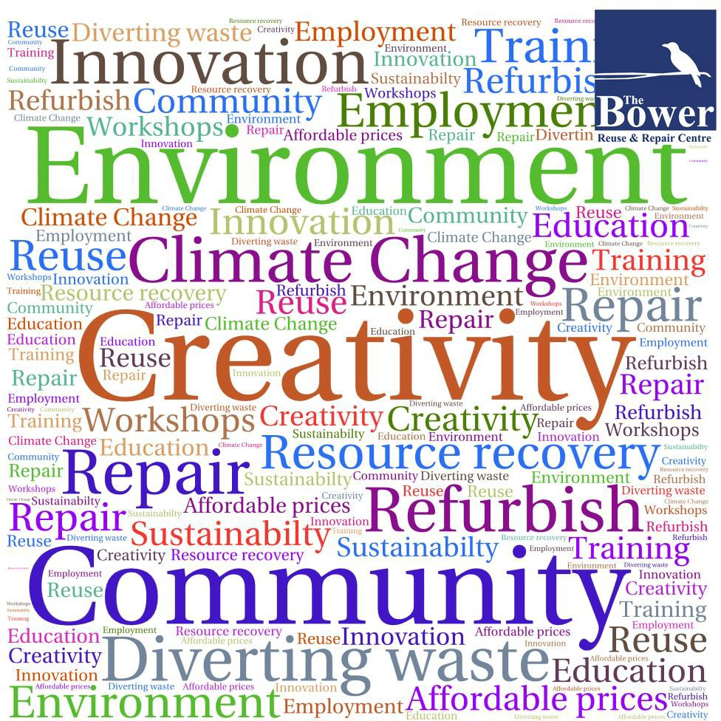

Given that The Bower is a not-for-profit organisation with a low budget, our marketing initiatives and promotions are limited. However, this has not stopped The Bower from reaching out to its target audience.

We have identified the following methods as the most effective ways to promote and market our business and services:

Media Platforms
The Bower’s website covers a wide range of topics from governance to sources for useful repair and reuse information.

The Bower’s Facebook page provides an insight into what happens in the centre, the

goods we receive and sell and interesting and relevant stories about our work and the centre.

The monthly online newsletter keeps members and supporters up to date on new initiatives.

Flyers
DL flyers, highlighting the range of services we offer, have been produced and are available in our store, on stalls and at workshops.

Word of mouth
By providing reliable, high-quality services and products at low prices, The Bower has been able to build a reputation as a respected organisation.

Creativity, innovation and inspiration
When we celebrated our 15th anniversary in September 2014 the local Federal Member for Grayndler, the Hon Anthony Albanese MP, acknowledged that The Bower is well known for its ability to combine sustainability with innovation. In our 24th year he is now Prime Minister.

The Bower has indeed established a positive reputation whereby innovation and sustainability go hand in hand with initiatives such as:
    - Our consignment program.
    - Our reuse and referral service.
    - Our repair and upcycled service.
    - Australia’s first Repair Café.
    - The first auction organised by a recycling centre.
    - The first Tiny House build with 100% recycled material and more produced annually.

These events generated a lot of onlineinterest which in turn helped promote our organisation.

Working with Councils
The shared goal of diverting waste from landfill, provides Councils and The Bower with the opportunity to co-ordinate effective promotion and marketing of both Council and Bower services. The Bower services of reuse, repair and referral are complementary to the range of services offered by Councils to their residents.

Councils have newsletters, magazine and websites allowing them to interact directly with every single resident. The Bower can provide customised texts, inserts and illustrations about our services making it easier for Councils to promote our services in addition to their own.

Working with Community groups
Working with and educating local communities are vital building blocks towards The Bower’s objective to support and promote sustainable communities. We support communities not only by offering goods at affordable prices, but also by creating opportunities for community participation in our reuse and repair programs.

Educational workshops
The Bower workshops, including ‘Rent a Bench’, introduce skills and techniques to engage communities in reuse and upcycling. They are also an ideal platform to communicate more broadly, the objectives of diverting waste from landfill and to promote the Bower’s services and programs.

Fundraising
Ultimately, the goal of our marketing and communications plan is to increase The Bower’s income, via shop sales, workshop bookings, on-line sales, crowdfunding, grants and sponsorship programs.

Priority will be given to fundraising activities marketing the primary income generating streams, including The Bower shopfront.

The following overview provides an insight into the current status and recommendations for The Bower’s future communications and marketing strategy.

Marketing Plan Summary

Product | Strategy | Action | Timing
Audience feedback | Survey | Workshop questionnaire.  Survey Monkey + in-store survey. | Annually
Messaging | Uphold reputation of innovation and sustainability | Promote buzzwords: Environment, Creativity, Community. | Ongoing
Stills and footage | update images | Commission new images. | Ongoing
Website | More user friendly | Overhaul. | New website 2022
Social Media | Main communication tools | Facebook and Instagram. | Ongoing
Media relations | Establish long term media relations | Research and introduce appropriate media on-line and off-line. | Ongoing
Newsletter | Monthly e-news | Grow email address database. | Ongoing
Membership | Grow membership | Research and grow our membership | Ongoing
Community groups | Engage with more community groups | Source two groups per year for combined activities. | ongoing
Working with Councils | Promote Collection & Rehoming Service | Review content for promotion. Meet representatives.  Promote positive stories. | ongoing
Fundraising | Promote primary objectives | Review hierarchy of fundraising activities.  Perform cost/benefit analysis. | End 2022 and review bi-annually

Managing our growth
The Bower’s 3-pillar organisational and business model (sustainable economy, community education, working with Councils) is a strong model in so many ways: customers and the local community want it, society needs it, and Councils want to invest in it.
The main challenge for The Bower’s growth path will be striking the right balance between collecting more pre-loved goods and creating a greater market for recycled and upcycled goods. The flow and turnover of goods will be more important than getting a fair price for each and every item.
The pace of the increasing number of people who want to donate goods will be controlled by the growth of the buyers’ market and the increased acceptance of buying second-hand.

Creating a sustainable economy
Strategic priority: Expanding the Bower’s collection and sales capacity.
The main limitation for The Bower’s further growth is storage space, space to repair and upcycle goods, and retail display space.
The following actions will be undertaken:
- On-line sales: marketing unique and quirky items for sale that can be delivered to your door. Increase our presence in Facebook Marketplace
- New programs which have been tested and trialed previously will be gradually rolled out on a larger scale. This includes a paid repair service and in-house refurbishing of donated goods and manufacturing of new goods from recycled materials.

- Economies of scale: the ultimate response to the growing influx of donated goods (a result of the expansion of our programs) will be the opening of a new premise elsewhere most likely at Summer Hill depot (to be confirmed) in cooperation with the Inner West Council.

- Undoubtedly Covid has impacted our sales and workshops and repair caffes since March 2020. Our build up of reserves and adaptability including online has greatly assisted us to now restart all of our workshop’s programs and outreach activities in the second half of 2022 and into 2023.

SWOT Analysis

Strength – internal  Supporting 21 Councils and growing  Growing our fundraising program  Stable governance, management, organisation Experience in sales, bookkeeping, collections and rehoming, communications  Free access to goods/software to set up stores Capacity to scale business model | Weaknesses - internal  Recruit and train new staff and workshop facilitators  Lack of storage space and space for larger workshops  Limited promotional budget  Limited communications staff and budget  Downturn in sales during Covid  We do not have the capacityto9 answer many of the collection requests
Opportunity – external  Growing interest from Councils in our services Growing consumer interest in 2nd hand & upcycle Consumers prefer a local presence  Strong brand - reputation  More space allows for accepting more goods | Threat – external  High expectations i.e. one stop shop solution Educating & informing local residents takes time Ideal locations beyond our financial means Reliant on WFD and CSO for support tasks Reliant on external financial support for start up

Community Education

Strategic priority: Expanding our Community Work
Working with and educating local communities has been essential to the success of The Bower. Community embedding and social inclusion is a vital building block of our organisation.

It is The Bower’s intention to continue these efforts and to expand them by widening the range of programs and broadening the number of people that have access to them.
The following actions will be undertaken:
- The use of The Bower’s website along with other media platforms (Facebook and Instagram) and a regular newsletter will play a vital role in our communications strategy.

- A large pool of instructors needs to be established and trained.

- Greater promotion of the “107 workspace” at Redfern as a hub for creative people, community groups and Work for the Dole participants who want to experiment, train and learn about reuse and upcycling of pre-loved goods and ultimately become players in the sustainable retail sector.

- The Bower will continue to promote the consignment section as a flagship program to inspire people and attract customers. Organizing a roadshow, expanding the pool of consignors and The Bower’s in-house refurbishing and manufacturing capacity will all be part of the program.

- Expanding our relationship with companies for in-kind and financial donations. Similarly, there are opportunities to set up partnerships with companies to offer our workshops as teambuilding exercises as well as supporting specific initiatives.

Partnering with Councils

Strategic priority: Consolidate and strengthen our relationships with Councils.
Long-term arrangements with Councils will not only provide us with ongoing access to household goods but will also give us financial stability and the confidence to invest in further expansion of our organisational and business model.

The conversion from reporting in volume to reporting in tonnage was an important step to strengthen our relationship with Councils. Improving and diversifying our reporting in combination with identifying ways to better promote and expand our Collection & Rehoming Service is another important step in that regard.

The impact of Council amalgamations took renegotiation of many contracts, but all have been renewed in the 2022-23 financial year.

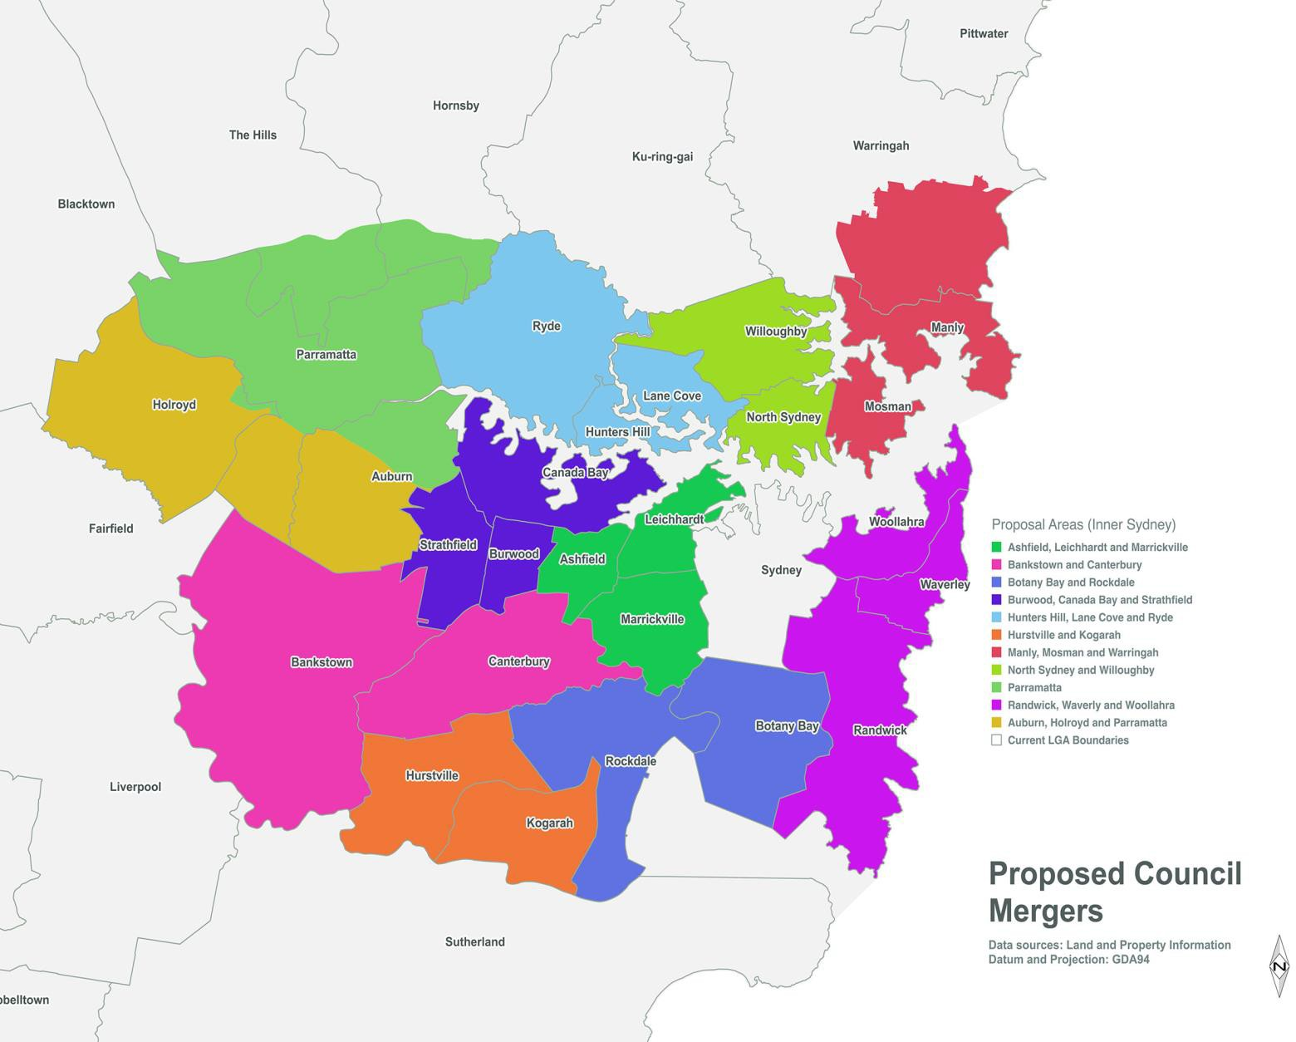

The following actions will be undertaken:

- We will continue to work with Councils on promotion and environmental education of their residents via workshops and information sharing via websites, magazines and flyers, a service which is highly regarded by Councils and has potential for growth.

- The provision of in-kind support from Councils for storage, pop-up shops or shopfronts and promotion material will be explored and will be subject to additional agreements above and beyond the basic CRS program.

- Given the growing interest in our Collection and Rehoming Service, we will explore ways to share our knowledge and expertise with more Councils and partner organisations for the benefit of other Australian communities and the environment at large.

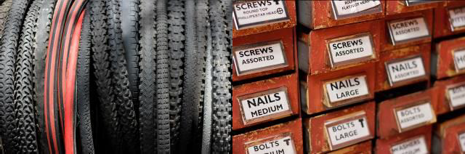

Key Council Performance Indicators

Council obligations are negotiated and accepted as part of the Collection and Rehoming Service Packages - Bronze, Silver and Gold.

Council Obligation
a. | Each Council allocates at least one officer to liaise with the Bower staff.
b. | Promote The Bower’s Collection and Rehoming Service amongst its residents via its website, newsletters and magazines.
c. | Display The Bower’s Collection and Rehoming Service flyer at local public spaces.
d. | Brief reception staff to advise residents to contact The Bower’s Collection and Rehoming Service with reusable items, and to use council clean-up services as a last resort.
e. | Review quarterly report and analyse data with The Bower’s Collection and Rehoming Service.
f. | Pay the CRS fee within 30 days of signing the contract.

Risk Assessment
The Risk Management Matrix identifies risks for The Bower further growth. A risk is any problem that may occur if no mitigation measures are put in place.

Likelihood | Impacts
 | Insignificant 1 | Minor 2 | Moderate 3 | Major 4 | Catastrophic 5
A. Almost Certain | High | High  No experience with opening shopfronts | Extreme | Extreme | Extreme
B. Likely | Moderate  Ongoing impact of Covid | High  Running three workshops (previously 4) at one time | High  Opening a further location | Extreme | Extreme
C. Possible | Low | Moderate  Experienced staff turnover | High  Too high expectations | Extreme | Extreme
D. Unlikely | Low | Low  Customer/ member dissatisfaction | Moderate  Sales below expectations | High  Councils decrease CRS support | Extreme  Financial support lessens
E. Rare | Low | Low | Moderate  Staff under- performance | High  No WFD/CSO  Volunteers (as during Covid) | High

Legend - Reference Aust. Standard AS/NZS 4360:1999 Risk Management

Qualitative measures of Risk Level |  |  | Qualitative measures of Likelihood
Level | Description |  | Level | Description | Detailed description
Low | Do something by routine procedures |  | A | Almost Certain | Is expected to occur
Moderate | Do something as soon as possible |  | B | Likely | Will probably occur
High | Attention needed |  | C | Possible | Might occur at some time
Extreme | Immediate action required |  | D | Unlikely | Could occur at some time
 |  |  | E | Rare | May occur in exceptional circumstances

Qualitative measures of Impact
Level | Description | Detailed description
1 | Insignificant | No financial or reputational impact, little disruption
2 | Minor | Minor financial or reputational impact, requiring some action to correct problem
3 | Moderate | Limited financial or reputational impact, creating inconvenience for organisation
4 | Major | Major financial or reputational impact, requiring thorough review and action
5 | Catastrophic | Catastrophic financial or reputational impact, requiring crisis management

